Gulliver’s Travels – Second Voyage Dinner Table Danger – Worksheet
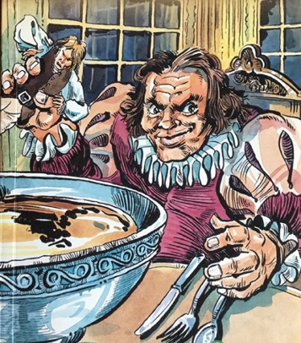
Gulliver is in the Brobdingnag, the land of the giants. Adopted by a young girl, Glumdalclitch, he moves into the royal palace. He is a favourite at court – but has one dangerous enemy.
Watch/Listen: Dinner Table Danger

Quick Check Questions – True or False
- The dwarf is bigger than Gulliver.
- The dwarf is angry with Gulliver.
- The dwarf tries to bully Gulliver.
- Gulliver pretends that the dwarf is his brother.
- The dwarf attacks Gulliver for no reason.
Who am I? Choose from the people below.
- I hate this new fellow at the palace. I want him to leave.
- I saw Gulliver fall – but I didn’t know what to do.
- I was on the other side of the room
- I helped Gulliver climb out of the bowl.
- I ruined my clothes.
Nurse * Gulliver * dwarf * Queen * Glumdalclitch *
Comprehension
- Why does the dwarf not want Gulliver at the palace?
- How does Gulliver provoke the dwarf?
- What does the dwarf do to Gulliver at the dinner table?
- Why does Gulliver survive the attack?
- Who drinks four pints of cream?
- Who is ‘ forced … to drink up the bowl of cream’
- Who sends the dwarf away to another family?
- Why is Gulliver happy when the dwarf leaves the palace?

Vocabulary

… this nasty little fellow – unpleasant, malevolent, unkind
… jealous of me – envious , to have a sense of injustice

Writing
You are either Glumdalclitch or the dwarf.
Write a diary entry about what happened at dinner from your point of view. (25-50 words)

